**Testing Document Assignment 3**

**TEST 1: Testing user input**

**Purpose/Objective:** The purpose of this test is to ensure that an XME file is produced with the extension xme from the first user input module.

**Test Configuration:** Run the program ‘UserInput.exe’, input two xmo files. The first one should create an xme.

**Expected Results:**

Successfully creates xme.

**Actual Results:** A capture of the output (i.e., actual results) of the program.

Prior to running.

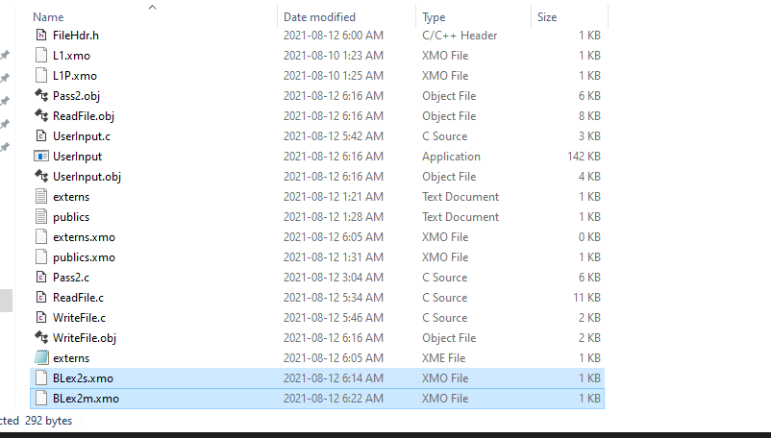

After running:

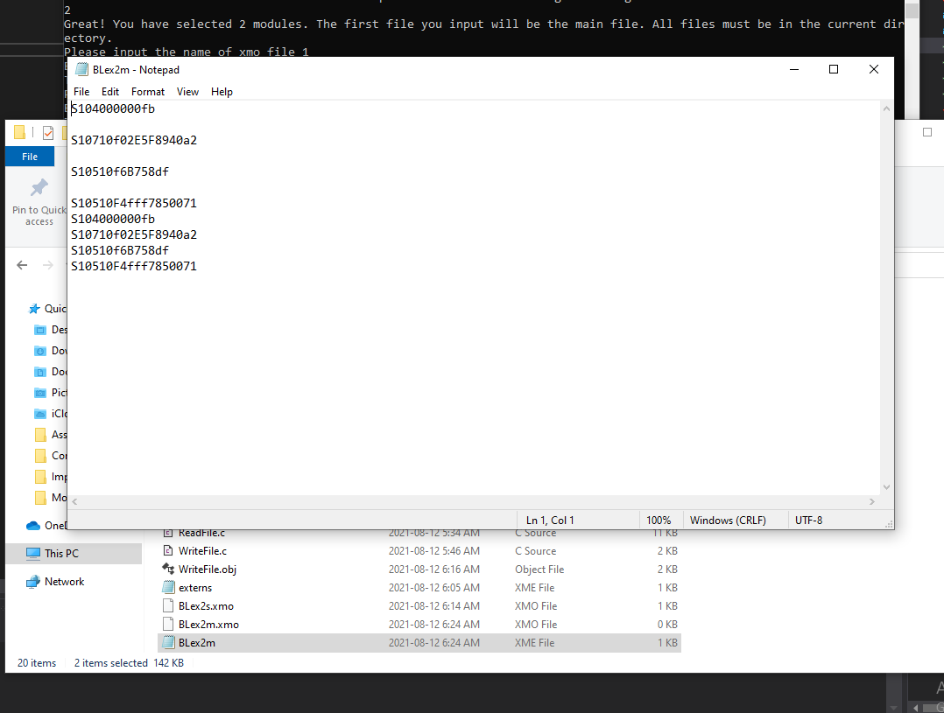

**Pass/Fail:** Pass

**TEST 2: Checksum is correct**

**Purpose/Objective:** Ensure that the newly calculated checksum is correct.

**Test Configuration:** Use externs.xmo and publics.xmo

**Expected Results:** The correct checksum is generated as seen on the last page of tutorial notes.

**Actual Results:** A capture of the output (i.e., actual results) of the program.

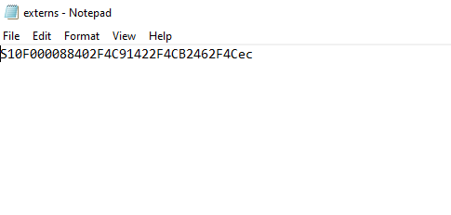

**Pass/Fail:** Fail . Clearly incorrect. Program has a bug.

**TEST 3: Does L3 produce S1?**

**Purpose/Objective:** The purpose of this test is to ensure that S1 records are produced from L3

**Test Configuration:** Use BLex2m and BLex2s . Double click executable. Input filenames.

**Expected Results:**

Accurate S1s produced.

**Actual Results:** A capture of the output (i.e., actual results) of the program.

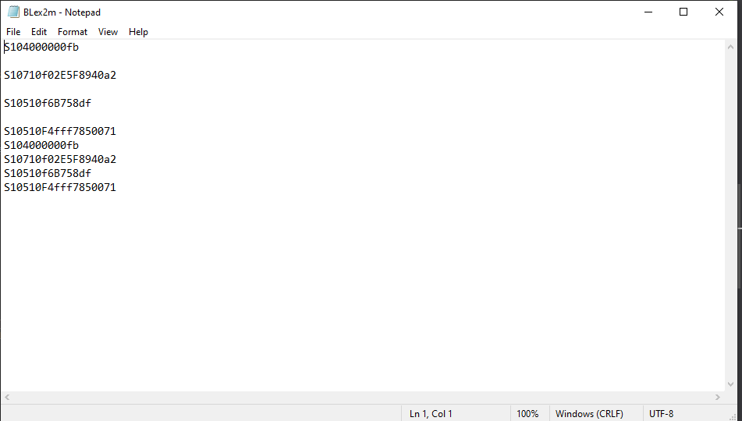

**Pass/Fail:** Pass on creating S1 records. Fail on accuracy.

**Other tests performed that appear to have failed in integration testing include:**

* Modifying the S1 record which was done successfully but there appears to be a bug in the final code, which is yielding inaccurate results.
* Valid checksum check.
* Valid S1 record produced.